🚀 JavaScript Learning Guide
This guide takes you from absolute beginner → intermediate developer using a structured, practical approach.

🧭 Roadmap Overview
Basics → DOM → Functions → ES6+ → Async JS → Projects

1. What is JavaScript?
JavaScript is a programming language used to make web pages interactive.
Used for:
- Web development (frontend + backend)
- Mobile apps
- Games
- APIs and servers (Node.js)

JavaScript in Web Architecture
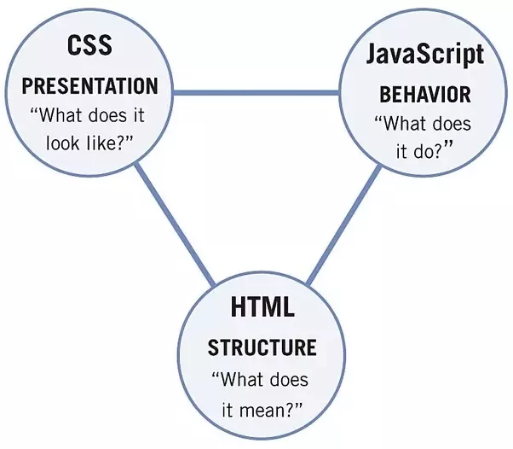
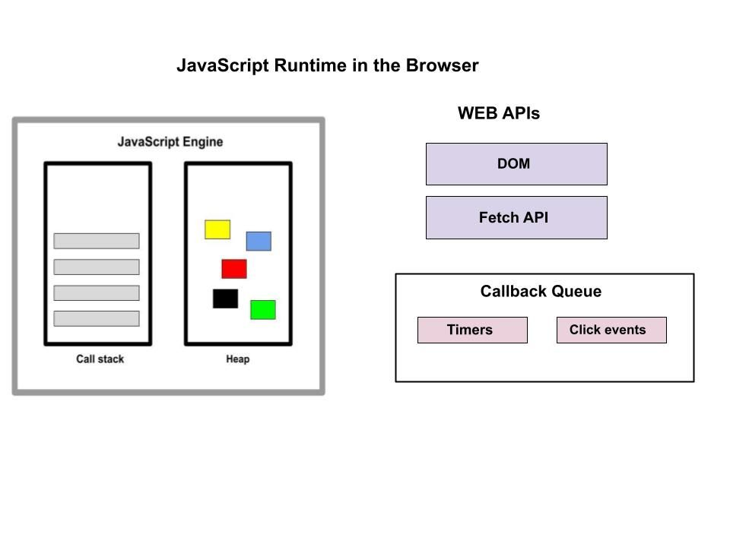
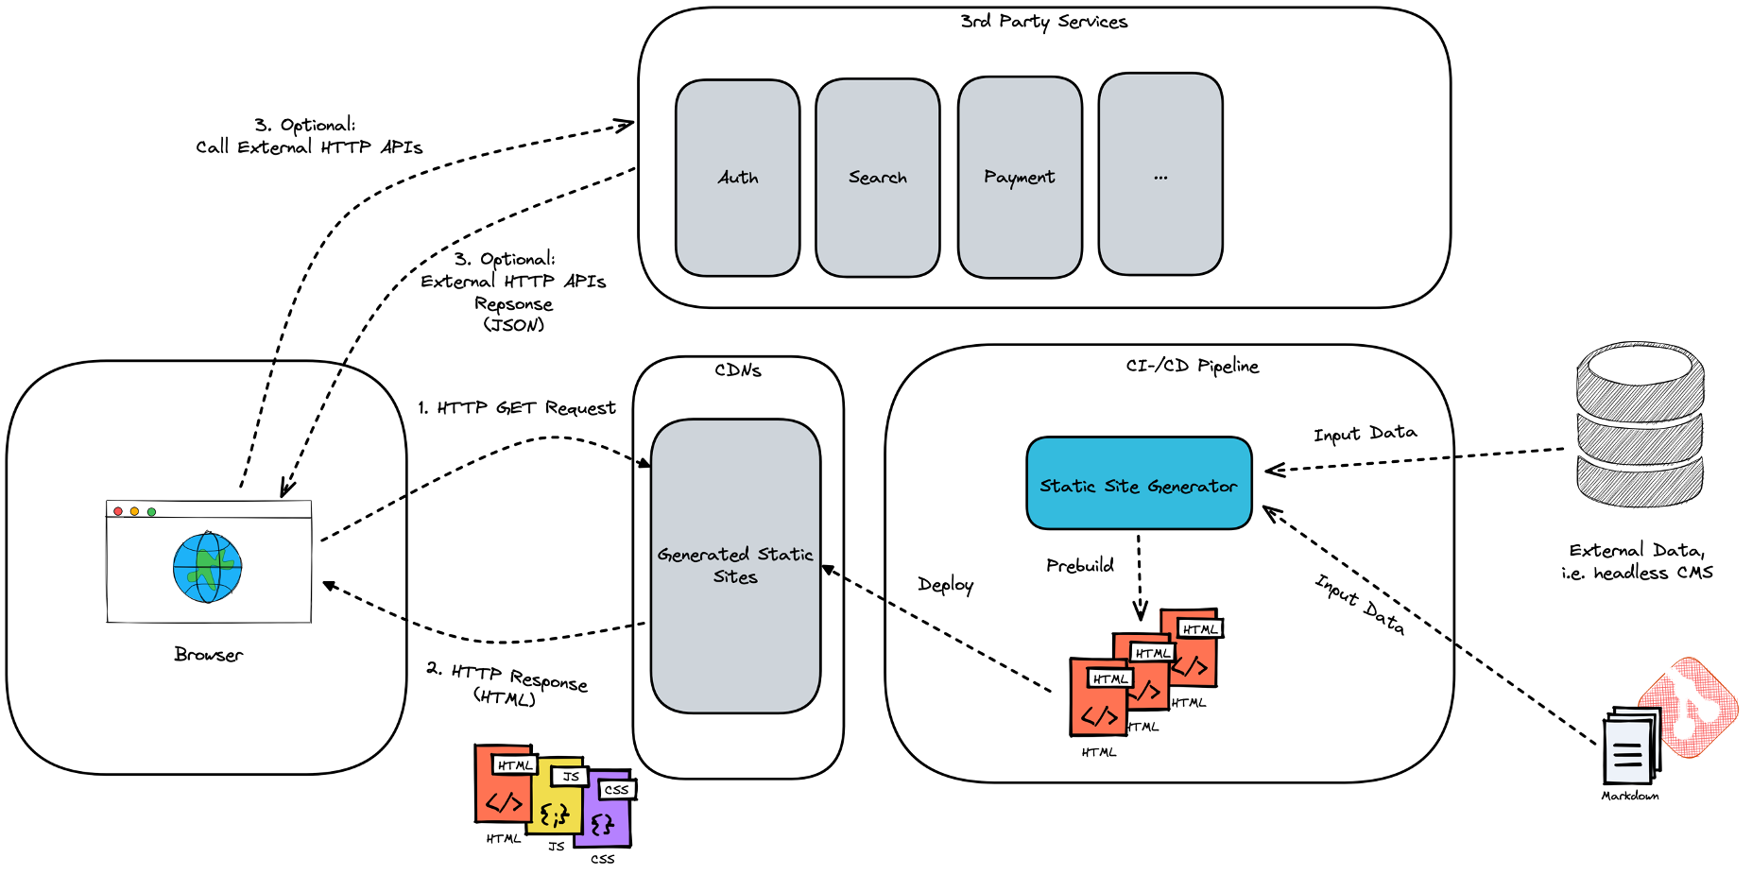
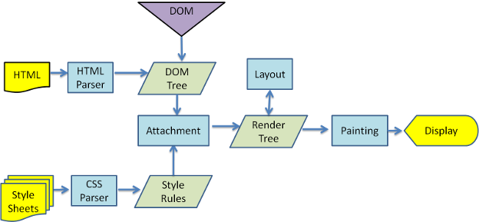

2. Setting Up Environment

Option 1: Browser Console
- Open Chrome → Press F12 → Console

Option 2: VS Code
Install:
- Node.js
- VS Code
- Live Server extension

3. Variables and Data Types

Variables
let name = "John";
const age = 25;
var city = "Delhi";

Data Types
let num = 10; // Number
let str = "Hello"; // String
let isTrue = true; // Boolean
let arr = [1,2,3]; // Array
let obj = {name:"A"}; // Object

Variable Memory Concept
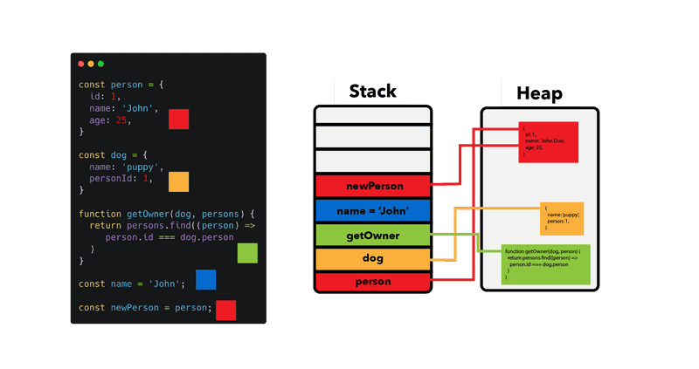
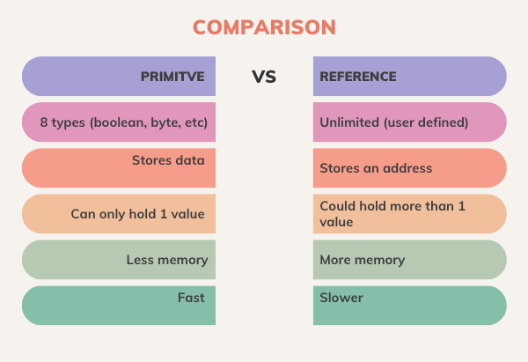
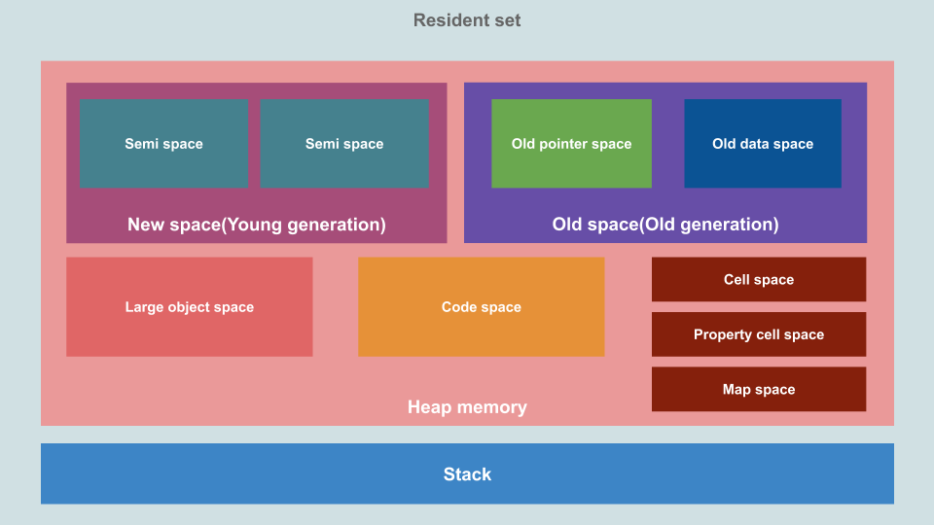
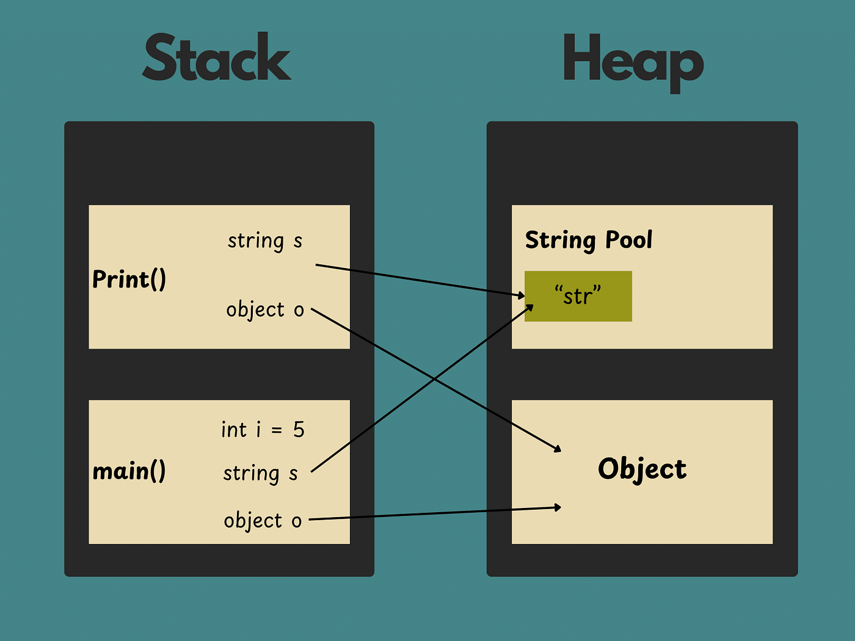

4. Operators
let a = 10, b = 5;

console.log(a + b); // 15
console.log(a > b); // true

5. Conditions
let age = 18;

if(age >= 18){
console.log("Adult");
} else {
console.log("Minor");
}

6. Loops
for(let i=0;i<5;i++){
console.log(i);
}

Loop Flow
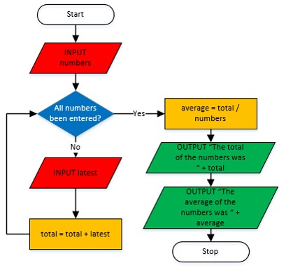
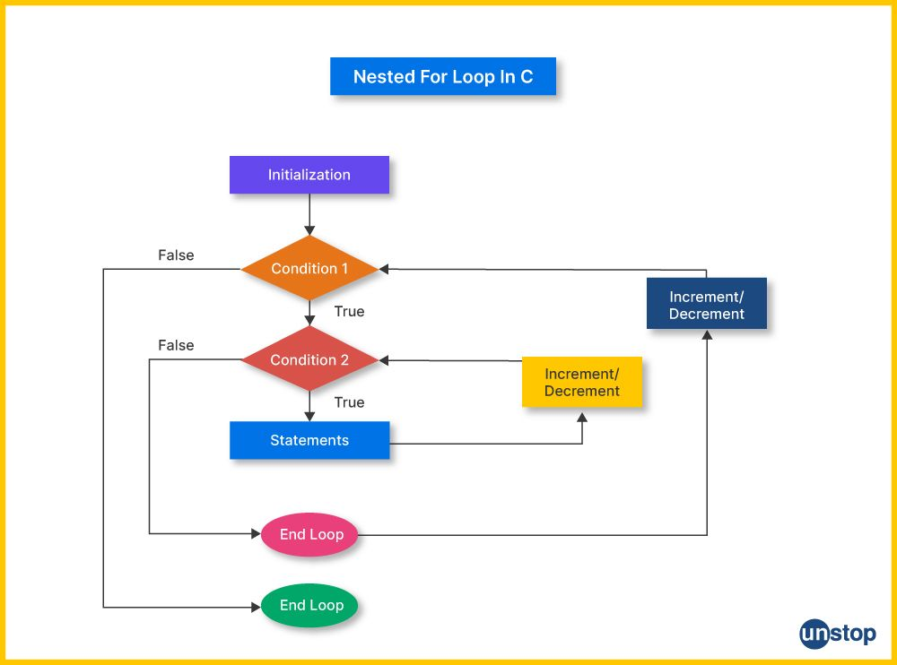

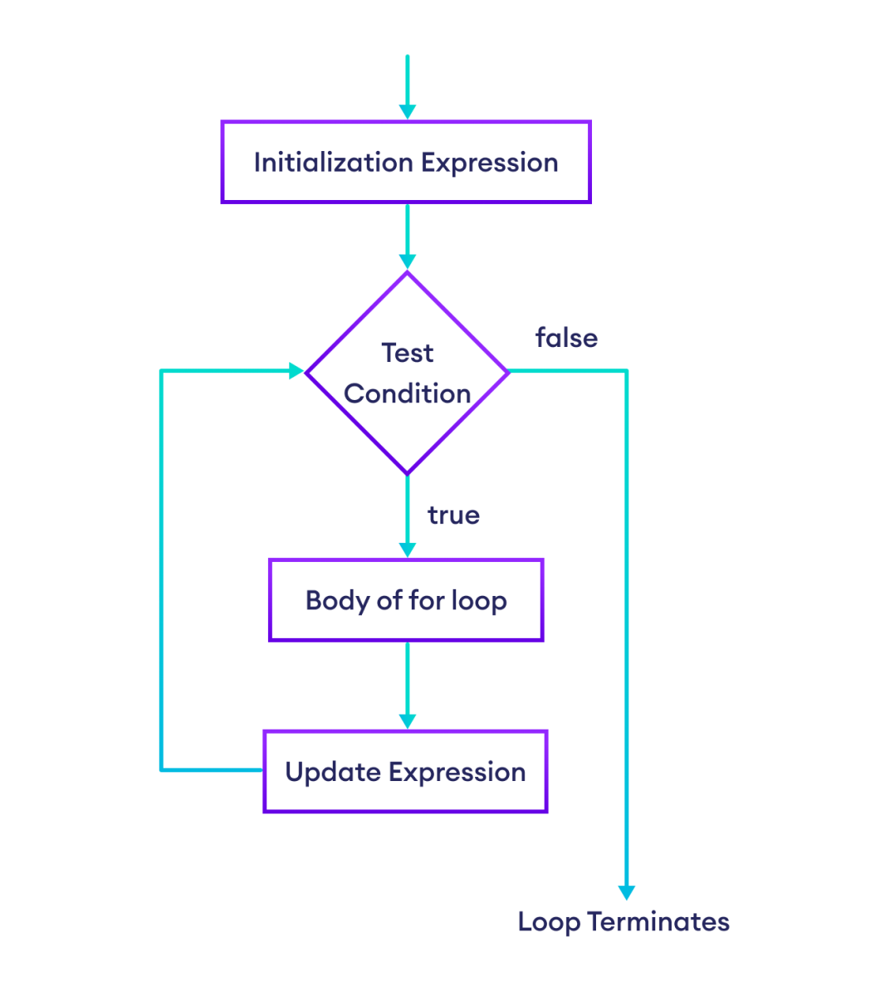

7. Functions
function add(a,b){
return a + b;
}

console.log(add(2,3));

Arrow Functions (ES6)
const add = (a,b) => a + b;

Function Execution
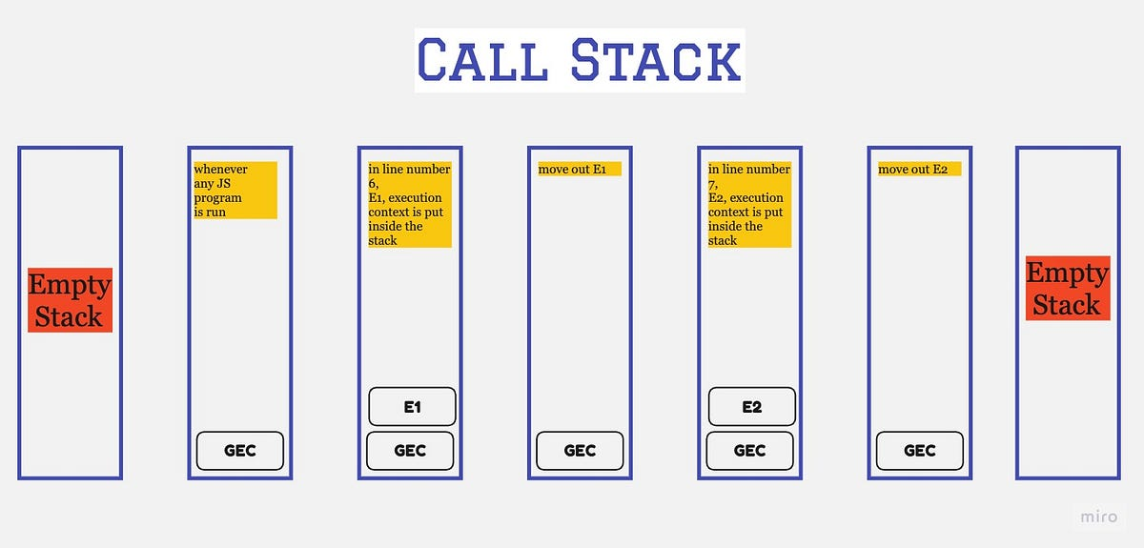

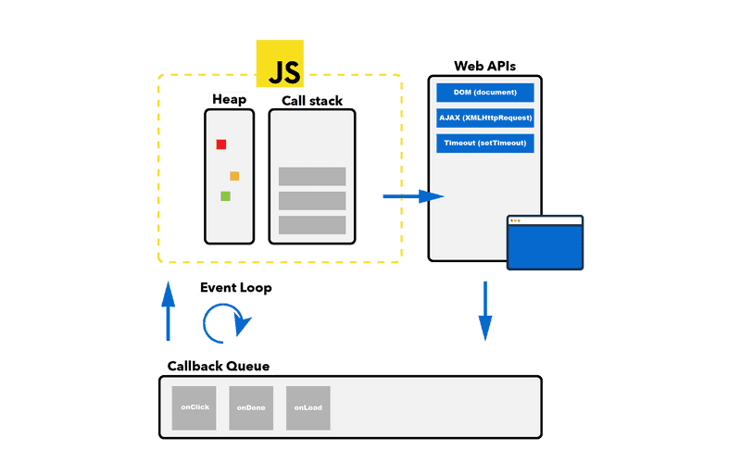

8. Arrays and Objects

Array
let fruits = ["Apple","Mango","Banana"];
console.log(fruits[0]);

Object
let user = {
name: "John",
age: 25
};

console.log(user.name);

9. DOM Manipulation
DOM = Document Object Model
document.getElementById("title").innerText = "Hello JS";

DOM Structure
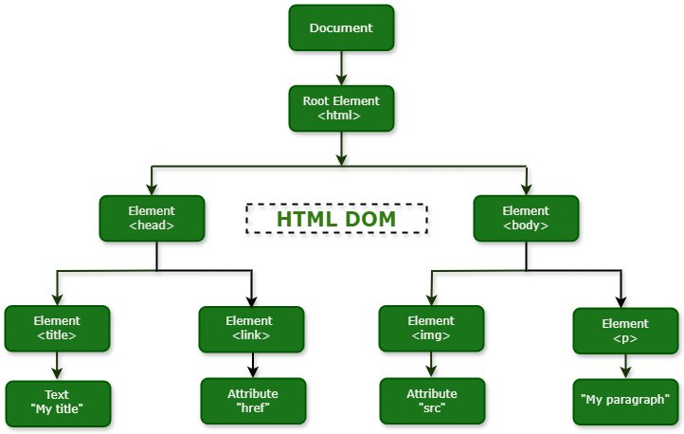
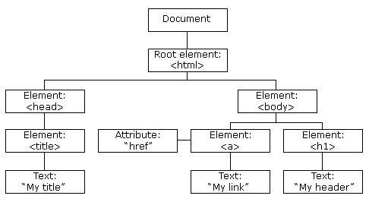

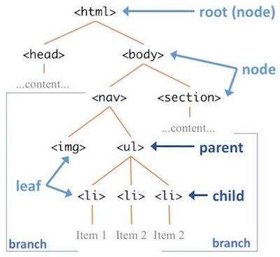

10. Events
document.getElementById("btn")
.addEventListener("click", () => {
alert("Button clicked");
});

11. ES6+ Features

Destructuring
let [a,b] = [1,2];

Spread Operator
let arr = [1,2];
let newArr = [...arr,3];

Template Literals
let name = "John";
console.log(`Hello ${name}`);

12. Asynchronous JavaScript

Callback
setTimeout(() => {
console.log("Hello");
}, 1000);

Promise
let promise = new Promise((resolve, reject) => {
resolve("Success");
});

promise.then(res => console.log(res));

Async/Await
async function fetchData(){
let res = await fetch("https://api.example.com");
let data = await res.json();
console.log(data);
}

Async Flow


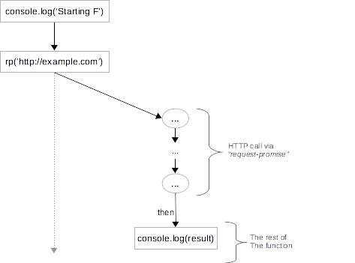
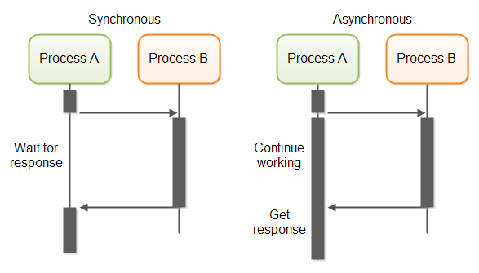

13. Error Handling
try {
let x = y;
} catch(e) {
console.log("Error occurred");
}

14. Working with APIs
fetch("https://jsonplaceholder.typicode.com/posts")
.then(res => res.json())
.then(data => console.log(data));

15. Mini Project (To Practice)

🧩 To-Do App
Features:
- Add task
- Delete task
- Mark complete

Example
let tasks = [];

function addTask(task){
tasks.push(task);
console.log(tasks);
}

🎯 Key Concepts to Master
- Closures
- Hoisting
- Event loop
- Promises vs async/await
- DOM manipulation

